**Design of Experiments Spring-2019 Dr. Matthew W. Wheeler**

**Team Project**

You are part of a team deciding where to locate a new Zip Lining Attraction, as well as determine the price of admission. Five sites, given as black dots in the figure below, have been located based upon their location and access to the Raleigh-Durham-Chapel Hill area.

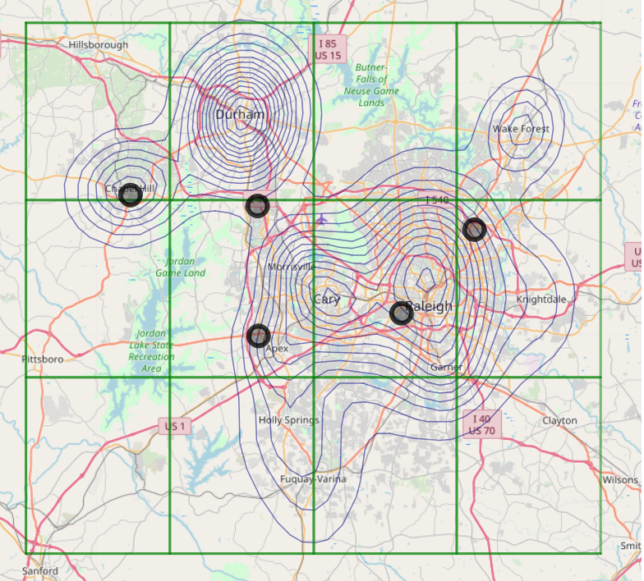

For this assignment, we assume there are approximately 1.5 million potential customers. We want to maximize profitability with this customer base by:

1. Finding the optimal location out of the five potential locations.
2. Determining the optimal price that will maximize attendance.
3. Determine the type of Zip Lining Experience desired:
   1. Family Friendly.
   2. Thrill Seeker.
   3. Middle of the Road Experience.
4. Determine which, if any, other attractions will help with attendance.
   1. None
   2. Arcade.
   3. Putt-Putt
   4. Arcade and Putt-Putt.

For this assignment the following simplifying assumptions should be made:

1. Distance will affect the likelihood a person will visit the park, and this distance can be measured using Euclidean distance of the latitude and longitude.
2. There are 4 fixed price points $15, $20, $25 and $30.
3. We expect a baseline of approximately 1% of the population to visit the park.
4. All three way interactions are insignificant.

**Deliverable 1- DUE: Wed January 23rd**

**Power Analysis and Experimental Design Plan:** Assuming a baseline of 1% of the population to visit the park with a maximum effect of 4% for any variable (some effects may be combined to be above this), design the experiment such that the effects of interest have reasonable power (i.e. 80% to be detected). Assume that each survey costs $10, and no more than 8,000 surveys can be conducted. This will be important in deliverable 2.

This should be no more than 4 pages, with the executive summary on the first page.

**Experimental Design:** With the provided file sample the population containing your experiment in the form of an Excel file. The format needs to be exactly as follows:

|  |  |  |  |  |
| --- | --- | --- | --- | --- |
| **UID** | **LOCATION** | **PRICE** | **EXPERIENCE** | **OTHER** |
| Unique ID in the database I gave you. EACH ID should be unique! | Codes as  (1,2,3,4,5)  1 = Location 1 etc. | Coded as (1,2,3,4)  1 = $15  2 = $20  3 = $25  4 = $30 | Coded as (1,2,3)  1 = Family Friendly  2 = Thrill Seeker  3 = Middle of the Road | Coded as (1,2,3,4)  1 = none  2 = Arcade  3 = Putt-Putt  4 = Arcade and Putt-Putt |

The GPS coordinates for the five potential locations are:

|  |  |  |
| --- | --- | --- |
| **Location** | **Longitude** | **Latitude** |
| 1 | -78.878130 | 35.89314 |
| 2 | -78.875880 | 35.74628 |
| 3 | -78.676540 | 35.7724 |
| 4 | -79.054280 | 35.90535 |
| 5 | -78.575981 | 35.86696 |

**Note:** You may have to make compromises. It may be that you cannot get 80% power for everything you feel is of interest.

**Deliverable 2**- DUE: February 15th.

Given the file you give me, I will return data from your experiment. This data is to be analyzed. Based upon your analysis you are to provide your recommendations. These recommendations will then be thrown into the same simulation (i.e., everyone gets the same random number seed), and total revenue for six months will be calculated. The teams (one orange and one blue) who maximized profit, which is revenue minus experiment cost, gets dinner at my house.

**Analysis:** No more than 2 pages with a 1 page appendix giving the final SAS PROC you used to analyze the dataset. I should be able to run the PROC on the data I gave you and get your results described in pages 1 and 2.